**Ring Measurer V0.1**

**(For internal testing only – do not distribute)**

**Contents**

Overview……………………………………………………………………………………………………

Citing Ring Measurer…………………………………………………………………………………..

Licence……………………………………………………………………………………………………….

Testing………………………………………………………………………………………………………..

Bug reporting……………………………………………………………………………………………..

Requirements and dependencies……………………………………………………………….

Set up…………………………………………………………………………………………………………

Installing Dependencies……………………………………………………………………………..

Launching the app………………………………………………………………………………………

Loading images…………………………………………………………………………………………..

Calibrating images………………………………………………………………………………………

Making measurements……………………………………………………………………………….

Adjusting measurements……………………………………………………………………………

Making annotations……………………………………………………………………………………

Saving data and exporting measurements………………………………………………….

Loading and validating AI measurements……………………………………………………

Using Ring Measurer data in RingdateR………………………………………………………

**Overview**

Ring Measurer is a Python based open source application to facilitate the manual and automated generation of growth ring width data. The app can be used to manually generate measurements, by means of clicking on the respective growth rings, modify previously generated measurements, and to validate machine learning based measurements. The data can then be imported into RingdateR for use in statistical crossdating.

**Citing Ring Measurer**

Reynolds D.J., De Ath, G., and Everson, R.The Application of Machine Learning in Growth Ring Identification and Analysis. *In prep*.

**Licence**

Ring Measurer is an open source application and available for editing and changing under the MIT licence.

We ask that if you use either the Ring Measurer app, source code or code for developing new growth line models, please cite the ring Measurer paper (citation above).

**Testing**

The app has currently been tested on several Windows 10 based operating systems. In theory, it should be Mac compatible…

**Bug reporting**

Please report any bugs, issues or suggestions for improvements to David Reynolds ([d.reynolds2@exeter.ac.uk](mailto:d.reynolds2@exeter.ac.uk)). If you are reporting a bug, please be as specific as possible for how you were using the app prior to the bug being noticed.

**Python Requirements**

Python version 3.9.16

**Initial Setup**

There are a few ways to run python files, here we will describe the method using Anaconda and Sypder IDE.

1. Download and Install python and Anaconda from the link: <https://www.anaconda.com/>
2. In Anaconda, set up a virtual environment, [see here for instructions on how to do this](https://docs.anaconda.com/free/navigator/tutorials/manage-environments/#:~:text=Creating%20a%20new%20environment,your%20Python%20or%20R%20installation.).
3. Once the virtual environment is setup, use Anaconda to install Spyder. Once installed launch the Spyder IDE.

**Install Dependencies**

A full list of dependencies can be accessed in the requirements.txt file. To install the dependencies open the “*setup.py*” file in the Spyder IDE and run the script. All the dependencies will be automatically installed. This step only has to be done once.

**Launching Ring Measurer App**

Once all the dependencies are installed, open the “run_ring_measurer_MW_app.py” file the in Spyder IDE and run the script.

The script will launch the Ring Measurer application and will open the Starting Point Window. No edits to the file are required, just simply run the script as it is.

If the window doesn’t appear, check it is not hidden behind the Spyder IDE.

**Loading images**

Use the “Open image” button on the starting point window to load an images. The app will work with JPG, TIF and PNG files.

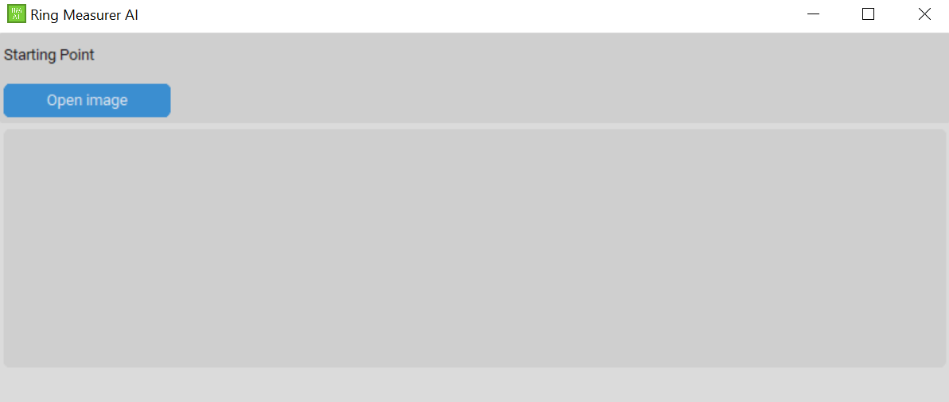

Thumbnails of the loaded image will display in the starting point page, whilst the image will open in a new window.

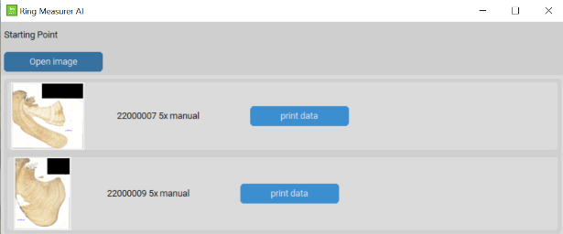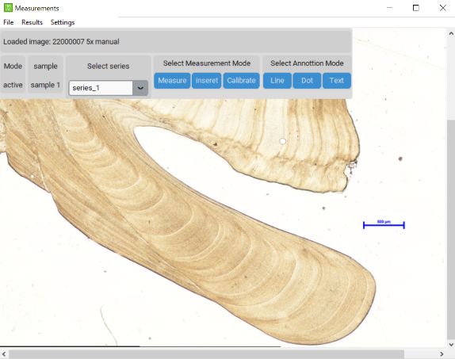

*Note the “Print data” buttons on the starting point page currently don’t do anything.*

The “open image” button can be used to open several images. Each image will open in a new window.

**Calibrating an image**

Images that contain a scale bar can be calibrated manually to ensure measurements are in micrometres rather than pixel values.

Click the “*Calibrate*” button in the tool bar to enter calibration mode.

It is best to zoom in on the scale bar to get more accurate calibrations. Then left click on one end of the scale bar to start a measurement, and left click the other end to end the measurement.

Enter the actual size of the scale bar in the text box (e.g. 500 in this example, do not put the units). Then hit submit. If the calibration has been entered properly the “no calibration set” text will change to show the new calibration. You can then close the text box.

**Manually measuring ring widths**

Click the “*Measure*” button to make sure the app is in measure mode. This will also be indicated under the Mode section in the toolbar.

Measurements can be made by left clicking to start a measurement and left clicking again to end a measurement.

The app is set up to allow replication of measurements using three series. Use the select series drop down box in the toolbar to change which series is being actively measured.

Once a measurement is placed it can be modified by holding down the ctrl or command key and left clicking and dragging the end of the measurement you want to adjust. The measurement will change colour when the mouse is over the correct part of the measurement before you adjust it.

The sensitivity of the mouse hovering/end of measurement detecting can be adjusted in the settings.

All the visuals for the measurement indicators can be adjusted in the settings (colour, line thickness, end cap size etc).

**Inserting measurements in the middle of a series**

If measurements need to be modified, either a measurement removed from the middle of a series or increments added this is possible.

To remove a measurement, hold down left shift and left mouse click on one of the ends of the measurement to be removed. It will change colour if the mouse is in the right pplace.

To insert measurements, click the “*Insert*” button in the toolbar.

Left click on the measurement that you want to insert measurements before. Then click the confirm selection in the box in the left of the screen.

Make the measurements as you would normally, you can make any number of measurements. But note, they most go in the same direction as the existing measurements.

Finally, click the “*Insert Measurements*“ button to insert the measurements into the series. All dates, and measurement numbers will then be automatically adjusted.

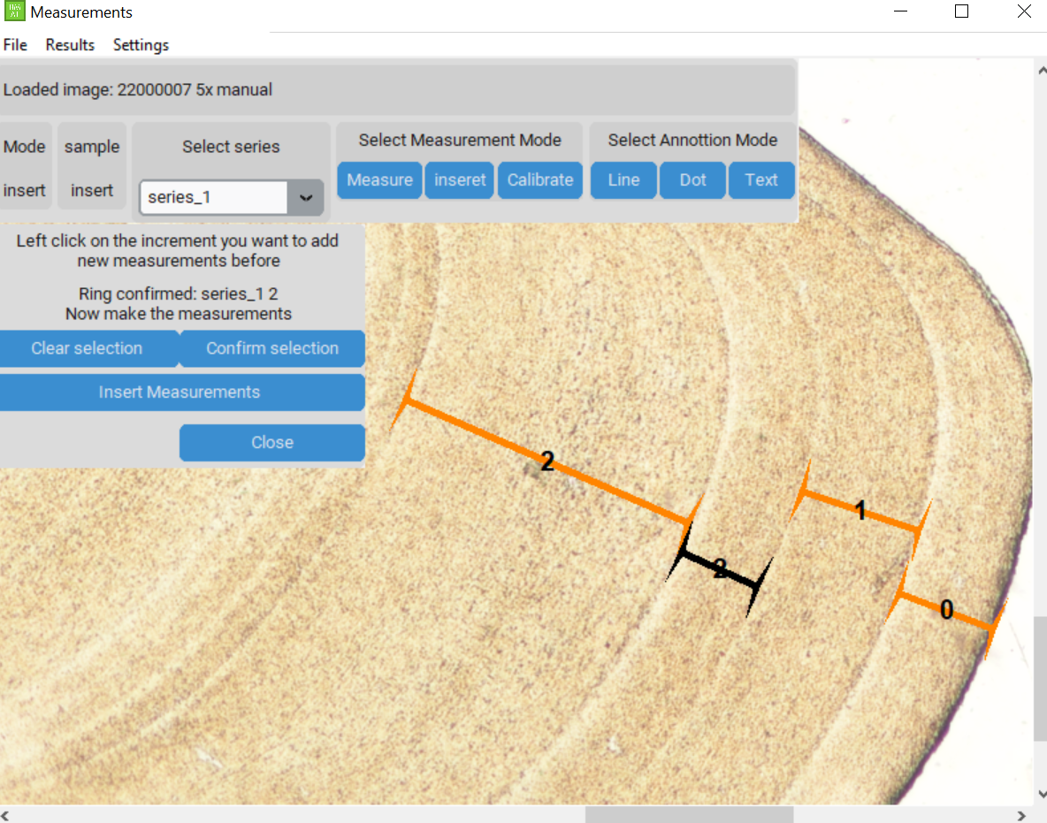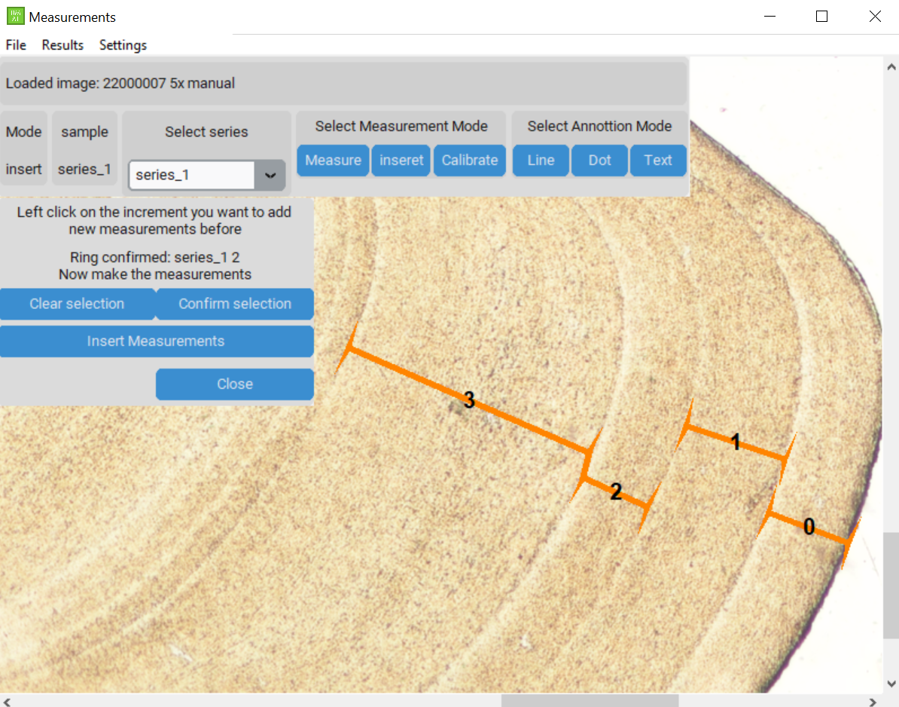

**Results window**

A table showing all the measurements can be accessed using the “*Results”* drop down menu.

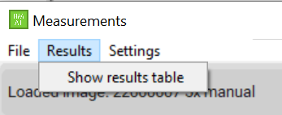

The Results table will open in a new window. The buttons at the top of the window allow the direction of the measurement series to be reversed as well as to change the year assigned to each individual ring. These year values can then be used in RingdateR for crossdating.

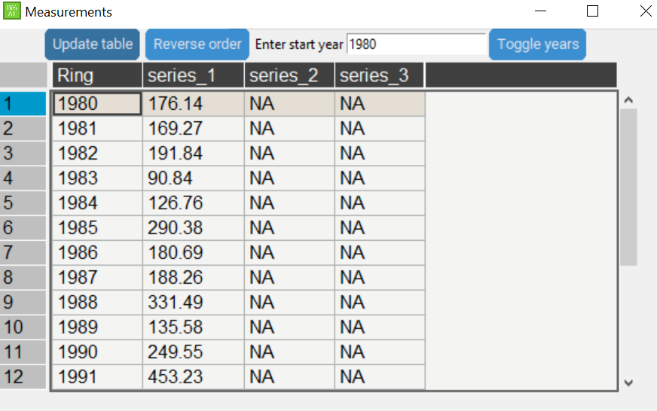

**Menu system**

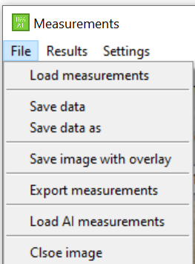

**Settings**

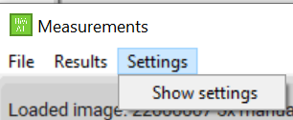

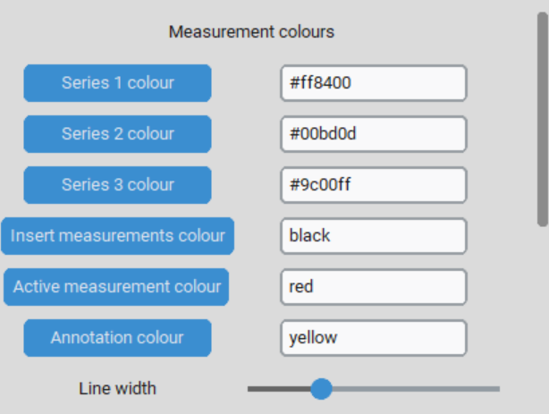

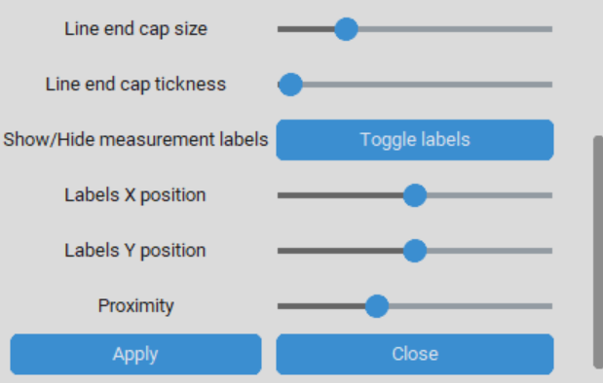

**keyboard shortcuts**

**Measuring**

|  |  |
| --- | --- |
| Make measurement | Left mouse click to start measurement, second left mouse click ends measurement. |
| Delete measurement/ delete annotation | Hold shift key and left mouse click on one of the ends of the measurement/annotation to be deleted.  **Note:** The measurement will go blue if the mouse is hovering over the measurement. Hovering over the middle of the measurement will do nothing. |
| Move a measurement/ move annotation | Hold control/ command key and click and drag left mouse button over the end of the line or annotation you want to move and drag it to the new position. Let go of the button to stop moving it. |

**Annotations**

|  |  |
| --- | --- |
| Insert dot | Select the dot annotation tool from the taskbar. Left click on the image to place the dot. |
| Insert line | Select the line annotation tool from the taskbar. Left mouse click to start drawing the line. Make a second left mouse click to end the line. |
| Insert text | Select the text annotation tool from the taskbar. Enter the text in the text box that appears in the top left of the screen. Then left click on the image where you want the text to appear. |
| Delete annotation | Hold shift key and left mouse click on the annotation to delete it. To delete a line annotation, you must click on one of the ends of the line. |
| Move annotation | Hold control/ command key and click and hold left mouse button over the end of the line or annotation you want to move and drag it to the new position. |